2026 ABWPA Scholarship Recipients
Congratulations to our TWO ‘Girl Power’ Scholarship

Recipients: Kayden Hockerman of Westfield, WI and
Sophie Heinold of Flemington, NJ.
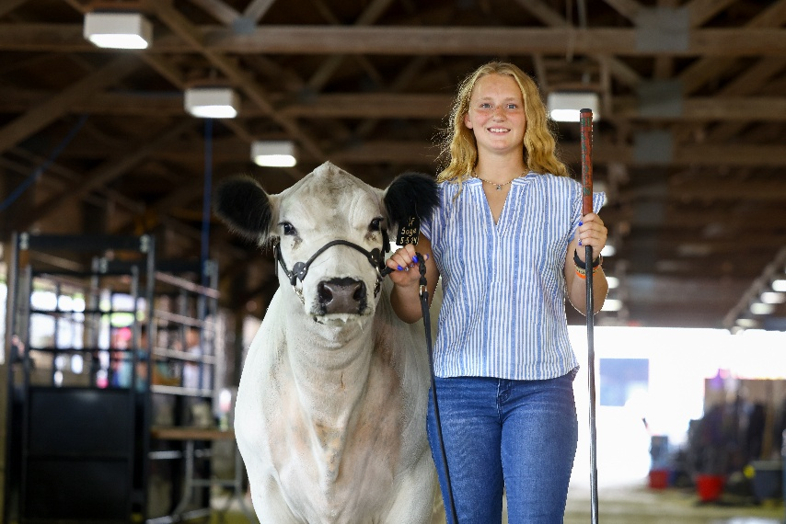
Kayden Hockerman, a senior at Westfield Area High School. Plans to continue her education at University of Wisconsin – Platteville studying Agricultural Education and continue her track career on the ‘Pioneer’ team.
Scholarship Essay Submission:
Please don’t be deceived by my young age and limited height, strong leadership comes in all shapes and sizes. My resume lists all my accomplishments on and off the court & field; in my community & classroom; and in the livestock show ring. But my resume may not communicate my ability to inspire the next generation of Westfield athletes; or my ability to influence and guide my show heifer to the top of the class; or my ability to give back to a school & community that has supported me the last seventeen years.
I got the short-end of the stick when it came to the height gene in my family and because of this I have had to work harder for my three-year starting position on a successful Westfield girls basketball team. Leading my team in rebounds and steals has earned me respect and recognition in the South-Central Conference as the two-time defensive player of the year. Taking this role to heart, I willingly put my team on my back each game by managing the opposing team's best offensive player. Playing a game that I love with grit and grace I am a role model to the youth sitting in the stands each night. My natural built farm-girl muscles and quickness has taken me to the next level in my high school track career. I solidified three new school records; captured multiple regional, sectional and state titles & appearances. But by far being a team captain has shaped and matured me the most over this past year. I have found my voice to guide my teammates through the ups and downs of a long season.
Being one of the youngest in my graduating class and in my immediate family I have had to work harder to “be seen”’. Outside of school I actively show Angus and British White cattle locally, state and nationally. In addition to showing my cattle I am a WI Junior Angus Ambassador and an American British White Ambassador. Representing these breeds on a national platform has allowed me to interact with leaders in the livestock industry across the country. From handing out awards in the show ring: public speaking in an arena full of people; displaying my heritage breed at the WI State Fair and WI Farm Technology Days while managing interviews from paper, radio and tv publications; to the early mornings and long nights in the barn in preparation for the next event. My leadership and dedication continue to lay the foundation for future livestock ambassadors.
Thank you to all the members that contributed and purchased auction items at the ABWPA banquet, the auction raised funds in support of the scholarships. If you have anything to contribute to the auction please contact Megan Hockerman, Youth Committee Chair.
Thank you for your continued SUPPORT!

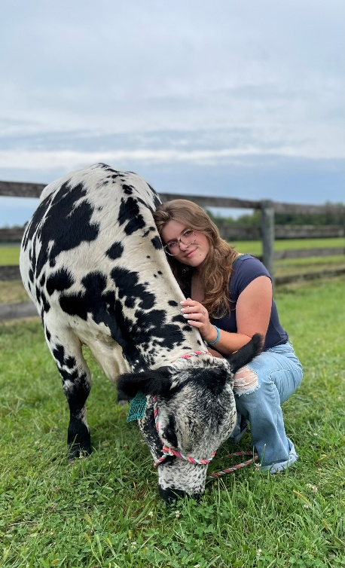
Sophia Heinold, is a student at Delaware Valley University, majoring in Animal Science and Pre-Veterinary with a strong focus on animal science and husbandry.
Scholarship Essay Submission:
I didn’t get into showing White Park cattle by buying a cow, having a farm, or being in 4-H since I was a little girl. I got in through an agriculture teacher who took a chance and lent me a cow. Ever since then, I’ve taken our show heifers to shows and events to gain experience and spread awareness of this breed.
I started 4-H and became involved in agriculture later than most, joining in my sophomore year of high school. Through one of my first jobs, I worked with a crossbred heifer and began learning. In my second year of high school, I met a teacher who said yes when I asked the crazy question, “Can I borrow your cow?” I didn’t have a farm, I didn’t have much experience, or the ability to buy her, but I had the passion and determination to make it work.
When she said yes, it changed my life. Through this experience, I gained knowledge, connections, and an appreciation for the White Park breed. Looking back to freshman year, I would be astonished at how far I’ve come—going from having no livestock experience to raising and showing White Park heifers and watching the one who started it all give birth.
At all the shows where this breed is represented, I’ve met countless people who have been kind and welcoming, encouraging me to stay involved every chance I get. The challenges I have faced to get to this point have shaped me into the person I am today and the leader I hope to become.
Although I did not grow up on a farm, I found my place in agriculture through my ag teacher, who opened the door to my future. I share my experiences and promote the breed at small fairs and events, showing young kids without direct connections to agriculture the opportunities available to them. I hope to show that, regardless of where they start, there is a place for them in the agricultural community.
In college, I am a pre-vet major and plan to minor in large animal science so I can one day start a large animal practice while also having the knowledge to run a farm of my own, which will undoubtedly be full of this breed. College is never easy to pay for, and I have come to understand this. As I enter my third year of college, I am increasingly aware of the financial challenges ahead. I have worked every odd job available during summers and winters, often working two or three jobs at a time to help pay tuition.
With the help of this scholarship, I can focus more on my grades and education rather than worrying if I have enough money for the next semester. This would allow me to participate in leadership opportunities, where I encourage other students to become involved in agriculture. Receiving this scholarship would not only help fund my future education but also support my goal of establishing a successful career while growing a White Park herd of my own.

